Electronic System Design Case Study Report-ALM-2
Harshavardhan
240004040454

Introduction
This report investigates ten practical electronic systems and real-world applications as required by the Active Learning Method Case Study (CO2). Each application is analyzed with respect to its function, operational principle, significance, schematic representation, and general design challenges. The report aims to build a comprehensive understanding of how theoretical concepts in electronic design are realized in actual appliances and industrial modules.

Case Study Application Table

No. | Application | Explanation | Work Function | Importance & Application
1 | Audio Amplifier | Increases the amplitude of low-level audio input signals for driving speakers. | Utilizes transistor/IC stages to amplify weak audio into audible output. | Fundamental in audio electronics, improves loudness and signal quality.
2 | Regulated Power Supply | Provides constant, stable voltage output regardless of load changes. | Uses transformer, rectifier, regulator ICs to deliver filtered DC supply. | Essential for powering sensitive electronics with consistent voltage.
3 | Temperature Sensor System | Monitors and transmits temperature data using thermistors/IC sensors. | Converts thermal variation into an analog/electrical signal for processing. | Key in HVAC, industrial safety, and environmental monitoring systems.
4 | Industrial Controller (PLC based) | Automates electromechanical processes with programmable logic. | Receives sensor inputs, processes logic, and actuates devices. | Increases efficiency, enables safety, and flexible control in factories.
5 | Home Automation Module | Enables remote and scheduled control of domestic appliances. | Integrates microcontrollers, wireless modules to switch loads. | Enhances comfort, energy efficiency, and security in smart homes.
6 | Medical ECG Monitor | Records electrical activity of the heart for diagnostic purposes. | Amplifies and filters biopotentials from patient; displays/output to monitor. | Critical for cardiac assessment and emergency care.

7 | Consumer Microwave Oven | Cooks food using high- frequency electromagnetic radiation. | Magnetron produces microwaves; system controls timing and power. | Integral to kitchens, allowing fast and safe food heating.
8 | Fire Alarm System | Detects smoke or heat to trigger alarms for fire safety. | Sensors activate electronic buzzer and visual alert on detection. | Life-saving safety device in residential and commercial spaces.
9 | Smart Energy Meter | Measures and communicates electrical energy usage remotely. | Senses, digitizes, and transmits energy data to utilities via wireless module. | Enables real-time energy monitoring and accurate billing.
10 | Automatic Water Level Controller | Regulates water tank filling automatically using level sensors. | Senses water level; controls pump relay to avoid overflow/dry run. | Saves water/energy, prevents motor damage, ideal for home/industry.

Expanded Example Application

1. Audio Amplifier
An audio amplifier circuit amplifies weak audio signals from microphones or players to levels suitable for driving a speaker.
Work Function:
Signal passes through one or more transistor/IC amplification stages. The output power is increased while maintaining original signal integrity.
Block Diagram:

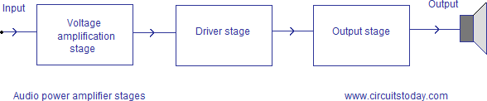

Schematic Diagram:
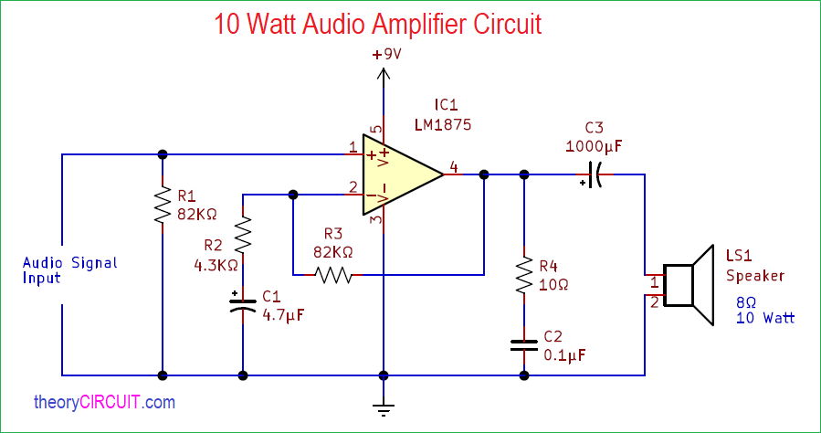

Conclusion
This series of case studies highlights how core principles in electronic system design are realized across various real-world applications. The exercise deepens understanding of practical engineering challenges, the significance of robust PCB design, and the critical role these systems play in society and modern industry. Good design, documentation, and reflection are crucial for successful, innovative electronic products.

